Tales of Harmonia Website

Proposed Designs for the new website

Prepared by Barry Fung

**Introduction**

In response to ***Tales of Harmonia: Website Redesign*,** design has been drafted and proposed for the possible redesign of the website currently serving the choir. To satisfy the criteria and objectives as proposed, several sections were considered – Site Map, Graphics, and Page Layout. This document will describe each solution and how it addresses the major objectives as defined by the design brief.

**Proposed Solution**

Sitemap Design: Design for Present

The design considers a focus on the present, and keeps both members and non-members up to date. In order to achieve this, the site map, as seen in Figure 1.

Home

About

Events

Members

Archive

* Sheet Music
* Music Recordings
* Membership Policy
* Constitution
* Useful Tools
* Past Seasons (M)
* Photo Gallery (M)
* Archived Events (M)
* Connect to our Youtube (Task)
* Extended Intro
* Video
* Current Roster
* Exec Team
* Conductor
* Upcoming Events (M)

Contact Us

* Office Hours
* Emails?
* Form
* Brief Descriptions
* Public Announcements
* General Concert Times
* Major Links

Figure Site map: Design for Present

As seen in the site map, the arrangement of pages focuses on ensuring separation between past and present, allowing visitors to the website to quickly access the most current info, yet access archives. The rationale behind this design is the scarcity of the previous actions occurring simultaneously – That is, visitors come either to search for current items in general, i.e. upcoming events / recent photographs, or to look at our archives, and see what we’ve done in the past to evaluate us.

**Categories**

In order to elaborate on the design, each major category will be explained:

**Home:**

The home page is meant to convey the most information in the shortest amount of time. This includes a choir description, performance dates, and public announcements.

**About:**

The About category fleshes out the description in the home page, and introduces the major parts of our current season for the public: roster, executive team, videos, and the like.

**Archive:**

The Archive category contains all past information, including past seasons, photos, and past events.

**Events:**

The events page contains a list of upcoming events, and links back to the archive.

**Members:**

The members category contains all internal documents, including sheet music, and the constitution, which is not necessary for the public to have access to.

**Contact Us:**

The contact us page connects to all of our social media platforms, as well as listing all office hours and providing a form to give feedback.

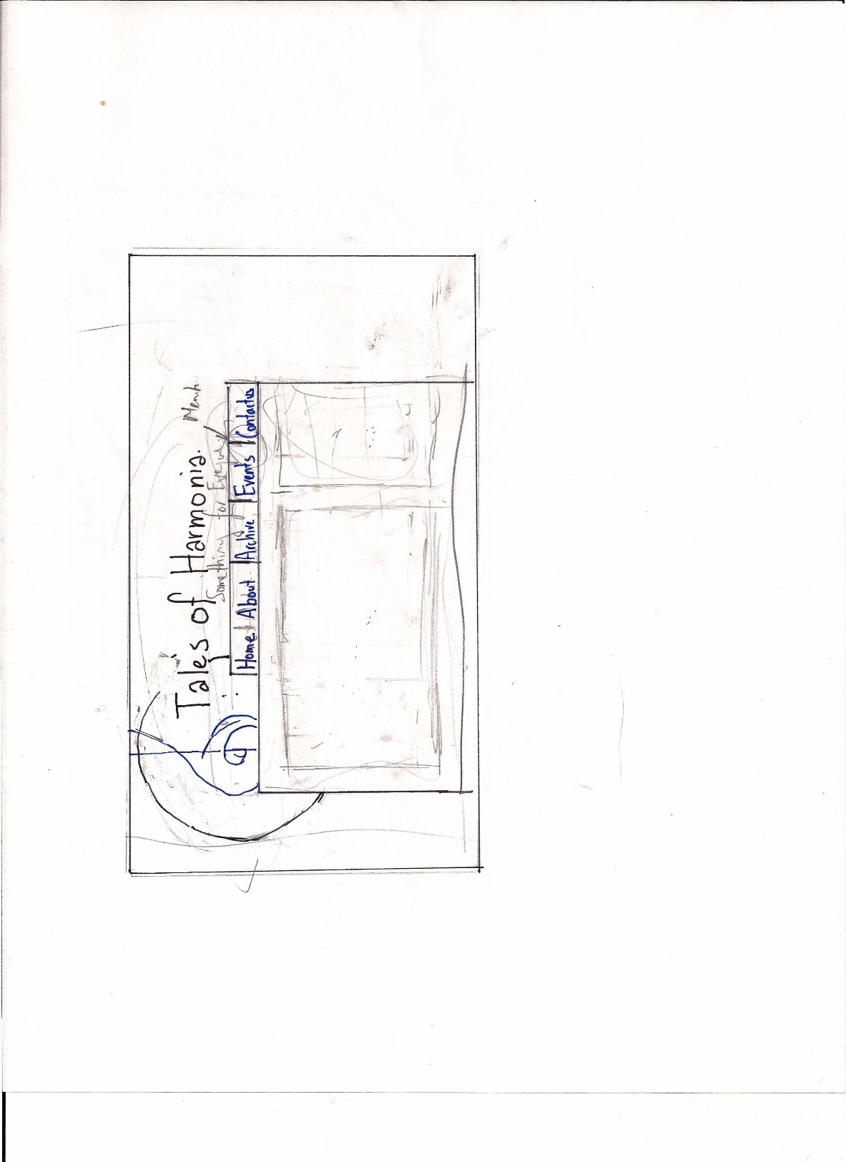**Graphic Design:**

There are currently two designs proposed for the graphics, catered to different methods. Design 1 is a function design, made to allow the most frequent user base, the members, to easily access the most important information, as seen in Figure 2. The main benefits of this design is the focus on the navigation bar, allowing members to access important information quickly, while allowing the choir to advertise its greatest parts – the members (utilising pictures as part of a slider.) However, this is a relatively simplistic design, often used.

Figure Hand-drawn template of Functional Design

The second of the major designs is the minamalist design, made to emphasize the people: as our motto is Something for Everyone, this allows us to communicate to non-members our values as well as our choir’s spirit. However, the design, as seen at <http://kingfung.wix.com/tohprototype> and in Figure 3 , prioritizes pictures above all else, and as a result, members have a slightly more difficult time grabbing vital information.

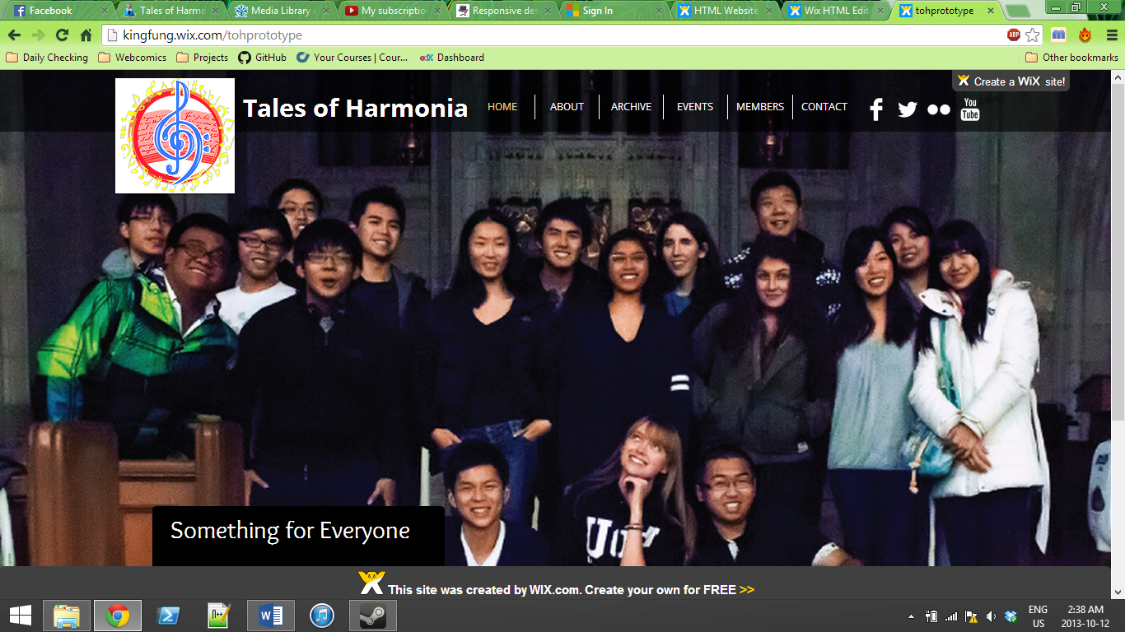

Figure Minimalist's Design, as realized in a rough prototype

**Conclusion**

As of this point, these solutions have been brought forward and developed – however, due to the possibilities of design, there isn’t much change